
Year 7

Investigation 2

Number and Algebra

Name: ______________________

Section One – Take Home Section
Question 1
Baldivis Secondary College is looking at the option for arranging the tables and chairs in the different classrooms.
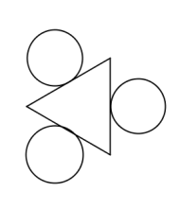
One option is to have triangular tables. With each table having 3 chairs.

With 2 tables



With 3 tables

- Draw the diagram for:

4 tables

5 tables

- Fill in the table showing the number of chairs and tables.

Number of tables (T) | Number of chairs (C)
1 | 3
2
3
4
5

- Describe any pattern that you can see in the table.

- How many chairs are required for 6 tables?

- How many chairs are required for 7 tables?

- Write a sentence describing the relationship between the number of tables and the number of chairs.

- Let C be the number of chairs and T be the number of tables. Write a rule using symbols and letters between the number of tables and the number of chairs.

- Using your rule, how many chairs would you need for 10 tables? Justify your answer.

- If I needed30 chairs, how many tables would I need?

Question 2


Another option is to arrange the tables and chairs differently. As shown in the diagrams below
With 1 table

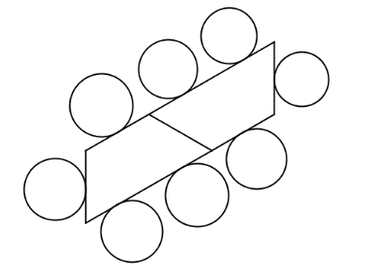
With 2 tables

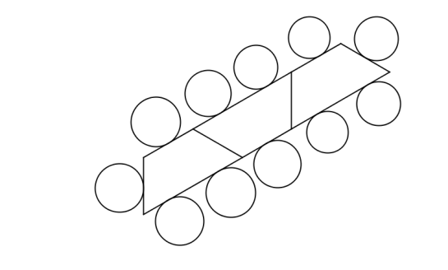
With 3 tables

- Draw the diagram for:

4 tables

5 tables

- Fill in the table showing the number of chairs and tables.

Number of tables (T) | Number of chairs (C)
1
2
3
4
5

- Describe any pattern that you can see in the table.

- How many chairs are required for 6 tables?

- How many chairs are required for 7 tables?

- Complete the following sentence describing the relationship between the number of tables and the number of chairs.

The number of chairs is equal to _____ times the number of tables plus _____.

- Let C be the number of chairs and T be the number of tables. Write a rule using symbols and letters between the number of tables and the number of chairs.

- Using your rule, how many chairs would you need for 12 tables? Justify your answer.

- If I needed32 chairs, how many tables would I need?

- Someone suggests that one way of working out the number of chairs is to add 1 to the number of tables and then multiply the answer by 3.
- Write this using symbols and letters

- Using the rule above, find the number of chairs that would be required for 12 tables.

- Does this new rule give the same answer that you found in part (g).

Year 7

Investigation 2

Number and Algebra
Total Marks: 30 marks

Section Two - In- Class validation
Question 1
(12 marks)
Baldivis Secondary College is looking at the option for arranging the tables and chairs in the different classrooms.
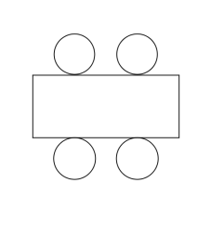
One option is to have rectangular tables. With each table having 4 chairs.

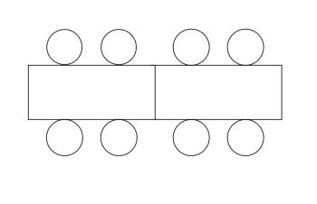
With 2 tables you need 8 chairs as in the diagram below

With 3 tables you need 12 chairs as in the diagram below
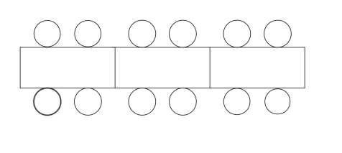

- Draw the diagram for:

4 tables

5 tables

- Fill in the table showing the number of chairs and tables.

Number of tables (T) | Number of chairs (C)
1 | 4
2
3
4
5

- Describe any pattern that you can see in the table.

- How many chairs are required for 6 tables?

- How many chairs are required for 7 tables?

- Write a sentence describing the relationship between the number of tables and the number of chairs.

- Let C be the number of chairs and T be the number of tables. Write a rule using symbols and letters between the number of tables and the number of chairs.

- Using your rule, how many chairs would you need for 12 tables? Justify your answer.

- If I needed32 chairs, how many tables would I need?

Question 2
(18 marks)
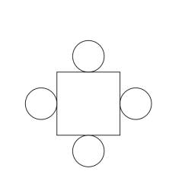
Another option is to arrange the chairs differently. As shown in the diagrams below
With 1 table

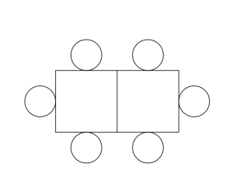
With 2 tables

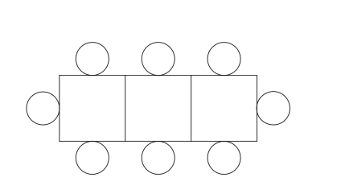
With 3 tables

- Draw the diagram for:

4 tables

5 tables

- Fill in the table showing the number of chairs and tables.

Number of tables (T) | Number of chairs (C)
1 | 4
2
3
4
5

- Describe any pattern that you can see in the table.

- How many chairs are required for 6 tables?

- How many chairs are required for 7 tables?

- Complete the following sentence describing the relationship between the number of tables and the number of chairs.

- Let C be the number of chairs and T be the number of tables. Write a rule using symbols and letters between the number of tables and the number of chairs.

- Using your rule, how many chairs would you need for 12 tables? Justify your answer.

- If I needed 32 chairs, how many tables would I need?

- Someone suggests that one way of working out the number of chairs is to add one to the number of tables and then double the answer.
- Write this using symbols and letters

- Find the number of chairs required for 12 tables.

- Is this rule for finding the number of chairs equivalent to the rule you found in part (g).

